**Team Expectation Agreement**

**TEAM NAME: UofToilets**

1. **CONTRACTUAL OBLIGATIONS**
2. **As a team, we agree to always set group meetings by:**
3. Speaking to each other respectfully and timely;
4. Via the Discord server, and will be set by Ethan at least 24 hours in advance.
5. Communication response time is expected to be within 24 hours.
6. We will meet at least 2 times per week for 15 minutes, and our regular group meeting will be on Mondays and Fridays at 7pm through Discord. Subject to change.

Mandatory: Yes

1. Meeting Preparations: Be prepared to present any progress you have made since the last meeting, what other work you intend to do after the current meeting, and if you need any assistance. If a team member is aware they are unable to attend an upcoming regular group meeting, they should be prepared to inform the rest of the team, along with their valid reasoning.
2. **Division of Work (Who does what, etc.):**
   1. Minutes of Meeting: Ethan
      * Back-up: Kieran
   2. Team Lead or Contact Person: Jerry
      * Back-up: Ethan
   3. Who will submit on Quercus: Victor
      * Back-up: Kieran

**Contingency Planning**

1. **If there is a change in the meeting, every person in the group will be notified:**
2. Via the Discord server, which will be sent by Ethan, up to 1 hour before
3. **We agree that 6 hours is the advance notice from any group member to cancel or reset the meeting.**
4. **We agree that to change or cancel a meeting, we need agreement from at least 2 team members.**
5. **We agree that a team member can miss:**
6. Maximum of 2 meetings, unless:
7. Medical or family emergency
8. Other extenuating circumstances, which requires prior approval from at least 1 other team members, and notification to Team Lead
9. **If a team member :**
   1. fails to attend the scheduled meeting(s) at the scheduled time;
   2. fails to complete work on time;
   3. fails to complete work in adequate manner and to quality standards set by the team;
   4. fails to contribute meaningfully to the thought process during the team meeting(s);
   5. behaves unprofessionally during meeting(s) or via written communication (i.e., does not pay attention, initiates conflict, etc.);
   6. fails to contribute the same level as everyone else in terms of effort, skills, cooperation, and results;
   7. fails to respond to communications for 5 consecutive days without prior notice;

**Any of the above listed items (a-g) will constitute Breach of Agreement. Unless excused by the rest of the group, or has a valid reason (e.g., Illness). It is up to the group members if they require proof for certain excuses. If any conflict arises please let the TA/Professor know.**

1. **CONSEQUENCES FOR BREACH OF AGREEMENT:**

This section specifies procedures and penalties you wish to implement in the case of "slackers" or team member(s) who deviate from the Team Agreement.

**Each of us agrees that if a team member is in breach of this team Agreement, we will take the following actions:**

1. Send the ***Written Warning*** (via email, etc.) to the individual outlining the complaint, providing evidence and supporting documents related to the problem, providing a time frame for the problem to be fully and completely remedied, and copy the TA & professor on the correspondence.

**Each of us agrees that if there is failure on my part to meet my obligations to the team project, I will do the following:**

1. ***Respond in writing*** (via email, etc.) to the warning and provide a detailed plan and timeline on how I will remedy any and all problems related to my underperformance and/or lack of contribution to the team assignment(s). Copy the TA & professor on the correspondence.

**Each of us understands that if the same or similar problem occurs one more time, or if the problem stated in the Written Warning is not fully rectified,**

1. The group must contact the professor if they intend to ‘fire’ or report a team member from the team (via email, etc.) that states the reason for firing.

*If a team member is fired from the team, the student in question may have complete the entire team-based project and any remaining team-based projects on their own (Consult the professor for more guidelines).*

In appending your signatures below, you are stating that:

*a) You participated in formulating the standards, roles, and procedures of this Agreement;*

*b) You have agreed to abide by these terms and conditions of this Agreement;*

c) *You understand that you will be subject to the consequences specified above and may be subject to reduction in overall course grade (including a failing grade) in the event that you do not fulfill the terms of this Agreement.*

**Signed:**

**Printed Name Signature Date**

Ethan Chan (chanet14) 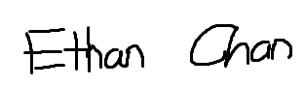 September 21 2023

Jerry Chen(chenjer8) Jerry Chen September 21 2023

Victor Yeung (yeungv10) Victor Yeung September 22 2023

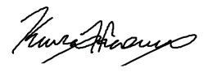

Kieran Hansen (hansen20) September 22, 2023

*Shuhong Duan 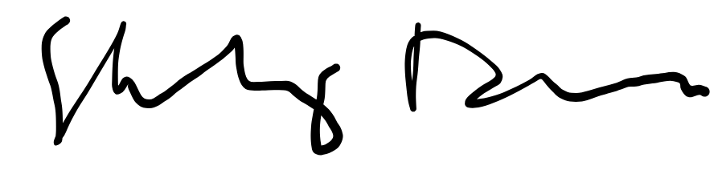* September 22, 2023

Zexi Zhang  September 24, 2023

_________________________________ _______________________________ _______________

*\* Signatures can be electronic or scanned*